

**JOB DESCRIPTION**

QUALITY MANAGEMENT SYSTEM

**Approved by**

Head of the Board Apparatus

____________N. N. Sakhanov

__________________2024

**MENTOR OF THE DORMITORY OF HIGHER COLLEGE OF TORAIGHYROV UNIVERSITY**

**Non-Profit Joint Stock Company "Toraighyrov University"**

**Pavlodar**

**2024**

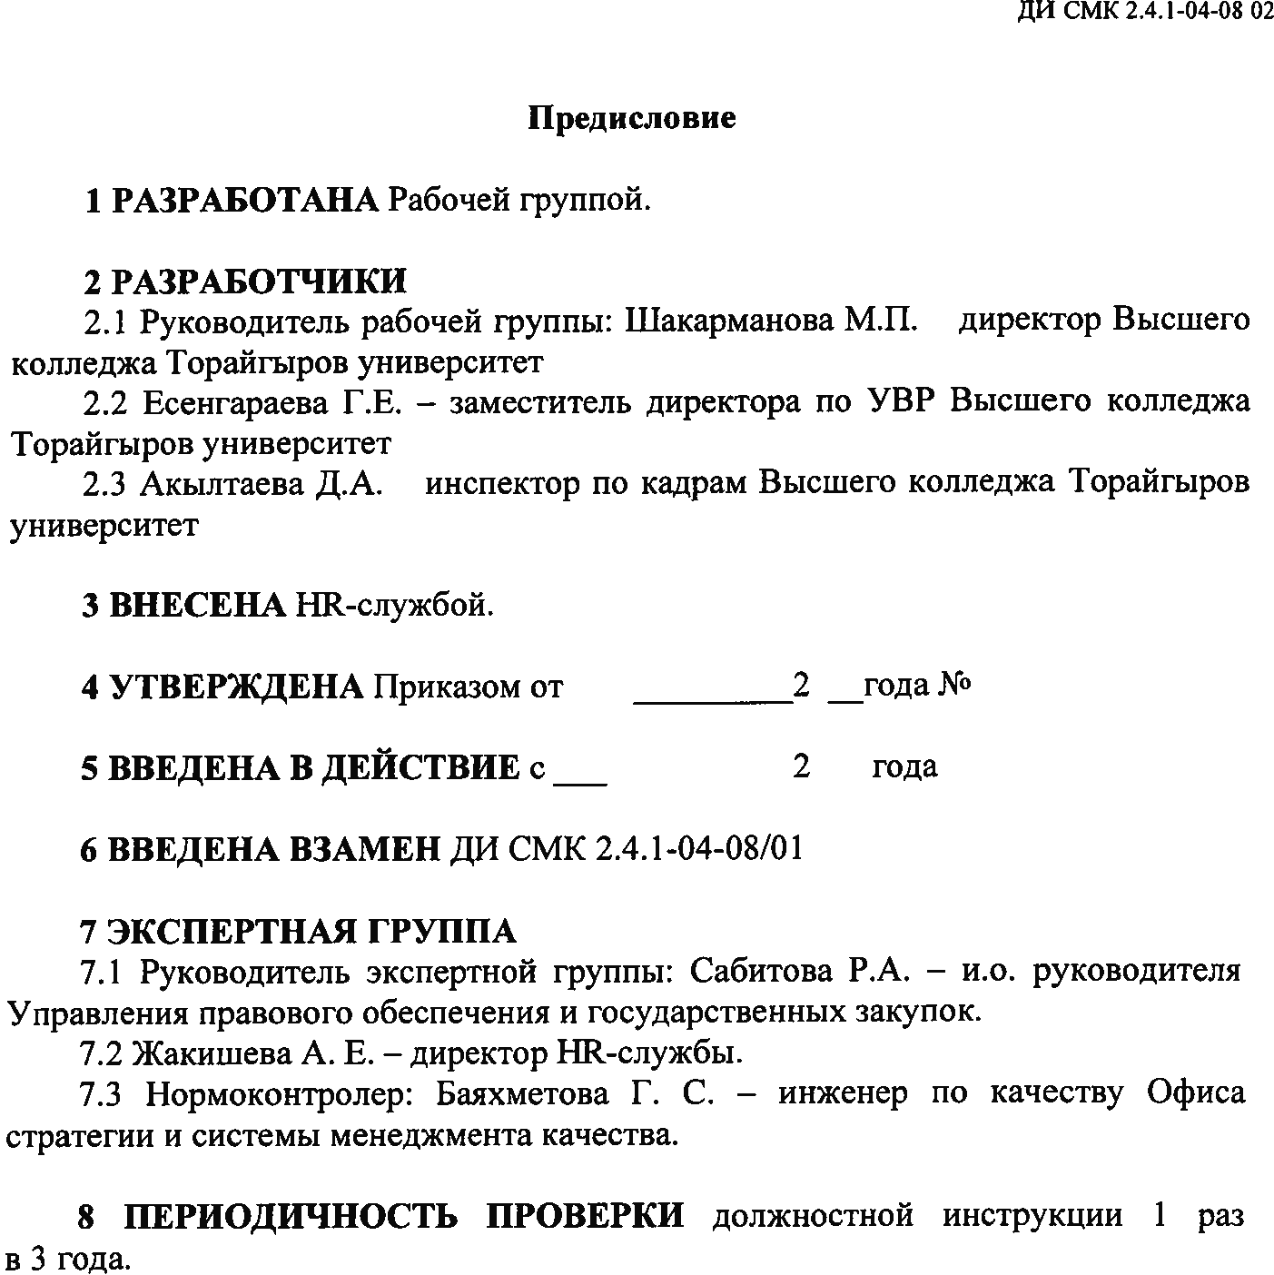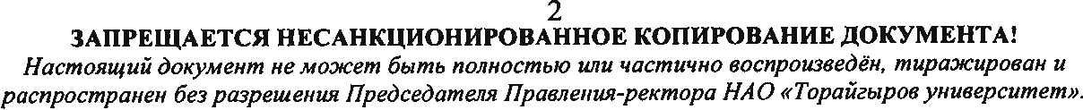

**PREFACE**

**1 DEVELOPED BY** the working group.

**2 DEVELOPERS.**

2.1 Head of the working group: M.P. Shakarmanova - Director of the Higher College of Toraighyrov University.

2.2 Yesengaraeva G.E. - Deputy Director for educational work of the Higher College of Toraighyrov University.

2.3 Akyltayeva D. A.-Human Resources Inspector of the Higher College of Toraighyrov University.

**3 INTRODUCED BY** the HR service.

**4 APPROVED** by Order No. 9-26\39 dated 01.09.2023

**5 PUT INTO EFFECT** since 01.09.2023

**6 INTRODUCED TO REPLACE** JD QMS 2.4.1-04-08 \01

**7 EXPERT GROUP**

7.1 Head of the expert group - Sabitova R.A. - Acting Head of the Department of Legal Support and Public Procurement.

7.2 A.E. Zhakishev - Director HR service.

7.3 Regulatory Document Control: G.S. Bayakhmetova - Quality Engineer of the Office of Strategy and Quality Management System.

**8 THE FREQUENCY OF CHECKING** the job description 1 time in 3 years.

**1 GENERAL PROVISIONS**

1.1 The mentor of the dormitory of Toraighyrov University Higher College (hereinafter referred to as the Mentor) belongs to the category of methodologists.

1.2 The mentor is hired and dismissed by order of the Chairman of the Board - Rector of the NJSC "Toraighyrov University" in coordination with the director of the college.

1.3 A person with higher and (or) postgraduate pedagogical education or technical and vocational education in the pedagogical field (secondary special, secondary professional) is appointed to the position of a mentor, without presenting work experience requirements.

1.4 The tutor reports directly to the director of the college and the Deputy director for educational work.

1.5 The educator should know and be guided by his activities:

* The Constitution of the Republic of Kazakhstan (hereinafter - the Republic of Kazakhstan), adopted at the republican referendum on August 30, 1995:
* The Labor Code of the Republic of Kazakhstan dated November 23, 2015:
* The Law of the Republic of Kazakhstan "On Education" dated July 27, 2007:
* The Law of the Republic of Kazakhstan "On State Youth Policy" dated February 9, 2020:
* The Law of the Republic of Kazakhstan "On Culture" dated December 15, 2006:
* The Law of the Republic of Kazakhstan "On the Social Code" dated April 20, 2023:
* The Law of the Republic of Kazakhstan "On the Rights of the Child in the Republic of Kazakhstan" dated August 8, 2002:
* The Law of the Republic of Kazakhstan "On Languages in the Republic of Kazakhstan" dated July 11, 1997:
* The Law of the Republic of Kazakhstan "On State Property" dated 01.03.2011 N413-IV 3:
* The Law of the Republic of Kazakhstan "On Combating Corruption" dated November 18, 2015:
* other regulatory legal acts of the Ministry of Science and Higher Education of the Republic of Kazakhstan:
* "On the definition of licensors in the field of education" GD RK dated October 26, 2018 No. 687:
* "On approval of the standard rules of the organization of education of the corresponding types of institutions" by Order of the Acting Ministry of Education of the Republic of Kazakhstan dated December 29, 2021 No. 614:
* Code of the Republic of Kazakhstan "On the Health of the people and the Healthcare system" dated July 7, 2020:
* The Charter of NJSC "Toraighyrov University":
* The internal Regulations of NJSC "Toraighyrov University":
* The Corporate Code of Ethics of NJSC "Toraighyrov University":
* The Mission, Policy and Goals of NJSC "Toraighyrov University"
* The Strategic development Plan of NJSC "Toraighyrov University" for 2019-2024:
* organizational and administrative documents of NJSC "Toraighyrov University":
* international standards in the field of quality management systems:
* documents ensuring the functioning of the quality management system of NJSC "Toraighyrov University":
* the hierarchy of the structure and directions of activity of NJSC "Toraighyrov University":
* The regulations on the college: the theory of the position instruction:
* theory and methods of management of educational systems:
* theory and methodology of educational work:
* program-methodical literature on social work:
* rules and standards of occupational safety and health:
* for the period of absence (sick leave, business trip, vacation), the duties of a specialist are performed by a person appointed by order of the Chairman of the Board-Rector.

**2 Job responsibilities**

**2.1 General areas of work**

2.1.1 Organizes and conducts educational activities. and cultural work in the hostel:

2.1.2 improves the content, forms and methods of educational work:

2.1.3 promotes the realization of the rights of the child, organizes work with pupils, protects their legitimate rights and interests in accordance with the legislative acts of the Republic of Kazakhstan:

2.1.4 organizes work on the prevention of offenses among adolescents:

2.1.5 Monitors the individual development of students, creates optimal conditions for personality formation, contributing to the free and full disclosure of all students' abilities and their development together with the family:

2.1.6 Studies the interests, inclinations, talents of students in order to select certain types of activities for them both during their studies at the university and upon its completion.

2.1.7. Organizes celebrations dedicated to significant dates and holidays.

2.1.8 Prepares an annual report on the results of educational work and the solution of social issues.

2.1.9 Plans and organizes the life activities of students and carry out their education, create conditions for their socio-psychological rehabilitation, social and labor adaptation.

2.1.10 Uses a variety of examples, methods and means of education and upbringing.

2.1.11. Together with medical professionals, ensures the preservation and strengthening of students' health, carry out activities that promote their physical development, and participate in socially useful work.

2.1.13 To assist in the organization of self-management of the student body.

2.1.14 To study the individual characteristics, interests and inclinations of students, as well as, as far as possible and with the consent of students and persons living with them, their family circumstances and living conditions.

2.1.15 Interacts with the parents (persons replacing them) of students.

2.1.16 To organize and carry out rehabilitation, correctional and cultural work with students

2.1.17 Systematically carries out methodological work, generalizing advanced pedagogical experience, improving their own professional competence.

2.1.18 To carry out other official assignments of the rector of the university, the vice-rector for Education, the director of the college.

2.1.19 To involve representatives of public organizations and employees of institutions of additional education in working with the student team.

2.1.20 To participate in the development and preparation of the general plan of the college's educational work plan.

2.1.21 Takes part in the requirements for occupational safety and health, fire safety and industrial sanitation in the workplace, as well as the requirements of internal regulatory documents of NJSC "Toraighyrov University" and the laws of the Republic of Kazakhstan.

2.1.22 Compliance with the timely fluorographic examination of employees, and obtaining access to work:

**3 Rights**

A college mentor has the right to:

1. regularly receive information about the physical and mental health of students:
2. monitor the attendance of students' classes.
3. to define (develop together with a psychologist, social and medical workers) individual work programs with students.
4. to participate in the work of the university's self-government structures: pedagogical, administrative, educational and methodological, councils:
5. to take the initiative and make a proposal to improve the activities of the university.
6. to determine the individual mode of work with students.
7. create your own educational systems and programs:
8. to choose a form of improving pedagogical skills through professional development systems for educational workers, to participate in various group and collective forms of methodological work:
9. to promote the effectiveness of the educational process:
10. to fix deviations in the development and behavior of students, to carry out psychologically and pedagogically justified correction, in difficult cases to inform the administration about it.
11. to provide assistance to students about this administration:
12. to assist in social and legal protection:
13. keep documentation reflecting the progress and results of educational work.

**4 Responsibility**

The caregiver is responsible for:

1. improper performance or non-performance of their official duties provided: for by this position instruction:

2. violation of the rules of internal order in the House of students:

3. disclosure of information intended for official use of the University:

4. committing offenses in the course of carrying out their activities , as defined by the current legislation of the Republic of Kazakhstan:

5. causing material damage to the college, provided for by the current legislation of the Republic of Kazakhstan.

**5 Relationships**

5.1 The college mentor organizes his work with other departments in accordance with the procedure defined by the regulations on the Department of Youth Policy and social work.

5.2 The mentor of the dormitory interacts directly with the staff of the college

**Appendix A**  
(required)

F CS QMS 4.01.5/01

|  |  |  |
| --- | --- | --- |
| **APPROVAL SHEET** | | |
| Position, Full Name | Date of Approval | Signature |
| Acting Head of DLSPP ,  R. A. Sabitova |  | ____________________  (signature) |
| Director of HR,  A. E. Zhakisheva |  | ____________________  (signature) |
| Regulatory Document Control: Quality Engineer of Office of Strategy and Quality Management  G. S.Bayakhmetova |  | ____________________  (signature) |

**Appendix B**  
(required)

F CS QMS 4.01.5/02

|  |  |  |
| --- | --- | --- |
| **ACKNOWLEDGEMENT SHEET** | | |
| Full name of the person who has read the document | Date of familiarization with the document | Signature |
|  |  |  |
|  |  |  |
|  |  |  |
|  |  |  |
|  |  |  |
|  |  |  |
|  |  |  |
|  |  |  |
|  |  |  |
|  |  |  |
|  |  |  |
|  |  |  |
|  |  |  |
|  |  |  |
|  |  |  |
|  |  |  |
|  |  |  |
|  |  |  |
|  |  |  |
|  |  |  |
|  |  |  |
|  |  |  |

**Appendix C**  
(required)

F CS QMS 4.01.5/03

|  |  |  |  |  |
| --- | --- | --- | --- | --- |
| **ACCOUNTING SHEET FOR PERIODIC INSPECTIONS** | | | | |
| Order number and date | Check result | Date of entry | Full name of the person who made the entry | Signature of the person who made the entry |
|  |  |  |  |  |
|  |  |  |  |  |
|  |  |  |  |  |
|  |  |  |  |  |
|  |  |  |  |  |
|  |  |  |  |  |
|  |  |  |  |  |
|  |  |  |  |  |
|  |  |  |  |  |
|  |  |  |  |  |
|  |  |  |  |  |
|  |  |  |  |  |
|  |  |  |  |  |
|  |  |  |  |  |
|  |  |  |  |  |
|  |  |  |  |  |
|  |  |  |  |  |
|  |  |  |  |  |
|  |  |  |  |  |
|  |  |  |  |  |
|  |  |  |  |  |

**Appendix D**  
(required)

F CS QMS 4.01.5/04

|  |  |  |  |  |  |
| --- | --- | --- | --- | --- | --- |
| **THE LIST OF REGISTRATION OF CHANGES AND ADDITIONS** | | | | | |
| The sequence number of the change | The basis (no., date of the order) | Date of introduction of the change | Date of the change | Full name of the person who made the change | Signature of the person who made the change |
|  |  |  |  |  |  |
|  |  |  |  |  |  |
|  |  |  |  |  |  |
|  |  |  |  |  |  |
|  |  |  |  |  |  |
|  |  |  |  |  |  |
|  |  |  |  |  |  |
|  |  |  |  |  |  |
|  |  |  |  |  |  |
|  |  |  |  |  |  |
|  |  |  |  |  |  |
|  |  |  |  |  |  |
|  |  |  |  |  |  |
|  |  |  |  |  |  |
|  |  |  |  |  |  |
|  |  |  |  |  |  |
|  |  |  |  |  |  |
|  |  |  |  |  |  |
|  |  |  |  |  |  |